

SOFTWARE REQUIREMENT SPECIFICATION
Internal Training Management System
Version 1.0
Prepared by ThangND-HE194201

– Hanoi, May 2025 –
Table of Contents
I. Record of Changes 4
II. Software Requirement Specification 5
1. Requirement Overview 5
1.1 Context Diagram 5
1.2 User Requirements 6
1.2.1 Actors 6
1.2.2 Use Cases 7
1.2.3 Business rules 12
1.2.4 Business flow 15
1.2.5 State machine diagram 18
1.3 System Functionalities 19
1.3.1 Screens Flow 19
1.3.2 Screen Descriptions 19
1.3.3 Entity Relationship Diagram 22
2. Functional Specifications 24
2.1 System Administration 24
2.1.1 UC-01: View User List 24
2.1.2 UC-02: View Test Types List 26
2.1.3 UC-03: View Course Types List 30
2.2 Course and Test Management 35
2.2.1 UC-04: Create Course 35
2.2.2 UC-05: Create Test 37
2.2.3 UC-06: Validate Course & Test 40
2.2.4 UC-07: Assign Course & Test to Employees 42
2.3 Employee Learning & Assessment 44
2.3.1 UC-08: Enroll Courses 44
2.3.2 UC-09: Take the Tests 46
2.3.3 UC-10: Track Learning Process 51
2.4 Reporting and Monitoring 53
2.4.1 UC-11: Monitor Employee Progress 53
2.5 Internal News Management 55
2.5.1 UC-12: View Notifications List 55
3. Non-Functional Requirements 57
3.1 External Interfaces 57
3.2 Quality Attributes 58

I. Record of Changes
Date | A*  M, D | In charge | Change Description
*A - Added M - Modified D - Deleted

II. Software Requirement Specification

1. Requirement Overview

1.1 Context Diagram
The Internal Training Management System is a new software application developed to replace the current manual and fragmented methods used by VIVAS to manage internal employee training. The context diagram below illustrates the major external entities and system interfaces for release 1.0. The system is expected to evolve through multiple releases, potentially supporting advanced analytics, external training content integration, and mobile access to improve flexibility and engagement across all departments.

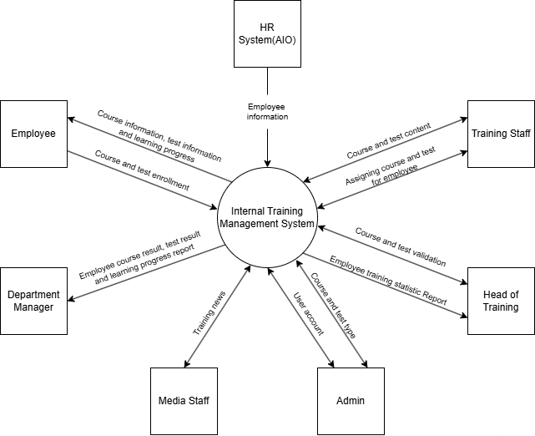

Picture 1.1. Context Diagram

1.2 User Requirements

1.2.1 Actors

# | Actor | Description
1 | Administrator | Manages users, assigns roles, manage course types, and manage test types
2 | Head of Training | Validate training courses and tests, views reports, monitors training progress
3 | Training Staff | Creates training courses and tests, assigns content to employees
4 | Department Manager | Monitors learning activities and exam results of employees in their department
5 | Employee | Attends training, takes exams, tracks their learning progress and scores
6 | Media Staff | Publishes internal news and articles related to training activities
7 | HR System (AIO) | Provides employee information to the training system

1.2.2 Use Cases
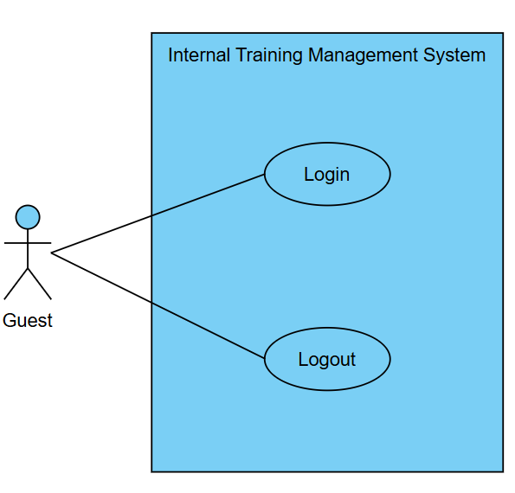
Picture 1.2.2.1. Use Case for Guest

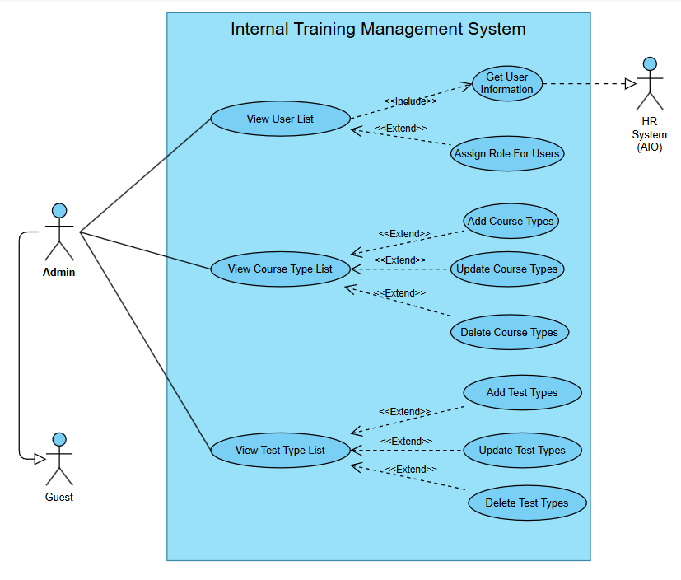
Picture 1.2.2.2. Use Case for Admin
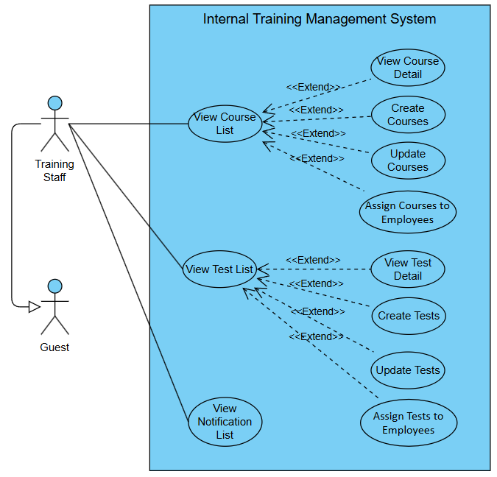
Picture 1.2.2.3. Use Case for Training Staff

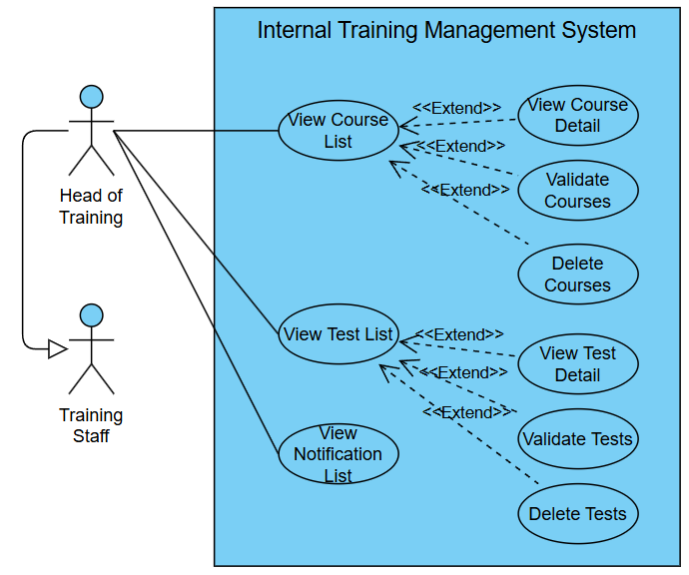
Picture 1.2.2.4. Use Case for Head of Training
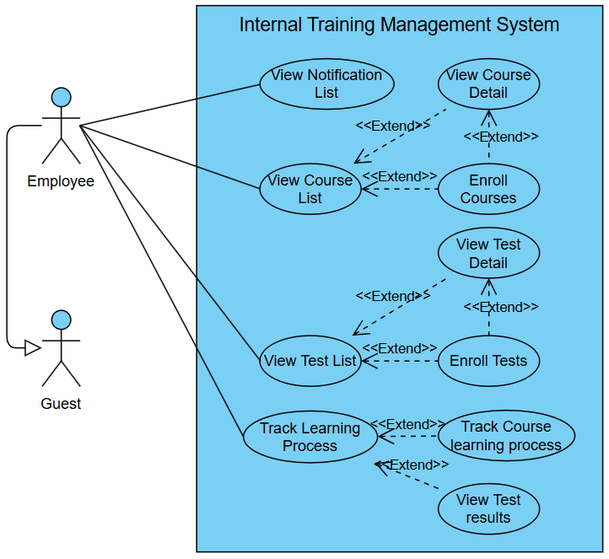
Picture 1.2.2.5. Use Case for Employee
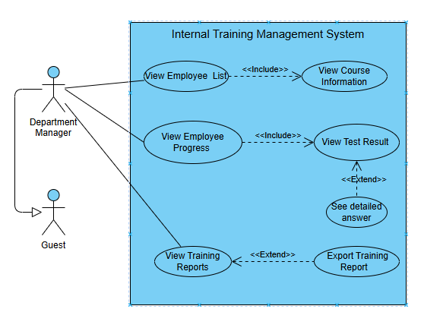
Picture 1.2.2.6. Use Case for Department Manager

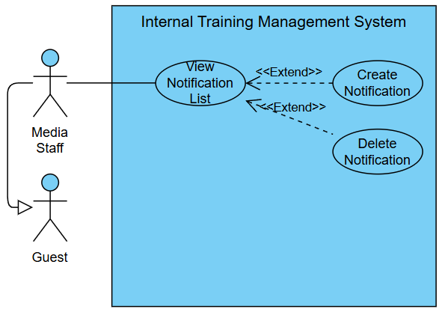
Picture 1.2.2.7. Use Case for Media Staff

In which
ID | Feature | Use Case | Description
01 | User Authentication | Login / Logout | Allows users to securely access and exit the system.
02 | User Management | Manage Users | Synchronize user information from the HR system (AIO).
03 | User Management | Assign Roles | Assign specific roles and permissions to users.
04 | System Configuration | Manage Course Types | Create, update, view, and delete course types (e.g., Technical, Soft Skill).
05 | System Configuration | Manage Test Types | Create, update, view, and delete test types (e.g., Mid-term, Final).
06 | Course Management | Create / Update Courses | Add new or modify existing course content and lessons.
07 | Course Management | Assign Courses to Employees | Assign specific courses to individual employees or entire departments.
08 | Course Management | Validate / Delete Courses | Approve or reject newly created courses, and delete existing ones.
09 | Test Management | Create / Update Tests | Add new or modify existing tests and their questions.
10 | Test Management | Assign Tests to Employees | Assign specific tests to individual employees.
11 | Test Management | Validate / Delete Tests | Approve or reject newly created tests, and delete existing ones.
12 | Employee Learning | View & Enroll in Courses | Allows employees to browse available courses and enroll in them.
13 | Employee Learning | Track Learning Process | Allows employees to access lessons sequentially and track their progress.
14 | Employee Assessment | View & Take Tests | Allows employees to see their assigned tests and take them.
15 | Employee Assessment | View Test Results | Allows employees to view their scores and pass/fail status for completed tests.
16 | Team Monitoring | View Employee List & Progress | Allows department managers to view the list of their employees and their learning progress.
17 | Team Monitoring | View Employee Test Results | Allows department managers to view the test results of employees in their department.
18 | Reporting | View & Export Training Reports | Allows managers to view and export summary reports on training activities.
19 | Internal Communication | Manage Notifications / News | Create, view, and delete internal news and announcements related to training.
20 | Internal Communication | View Notifications | Allows users (Employee, Training Staff, Head of Training) to view system-generated notifications and alerts.

1.2.3 Business rules
ID | Category | Rule Definition
BR-01 | Constraints | All courses and exams uploaded to the system must be approved by the Head of Training before they can be assigned or made available, except when the Head of Training is the creator, in which case approval is not required.
BR-02 | Constraints | Employees can only access and learn course content if they have completed the previous lessons or exams in the course sequence.
BR-03 | Action Enables | Employees can only view their own course information, learning progress, test enrollment, and test results, and cannot access data of other employees.
BR-04 | Action Enables | Department Managers can only access employee course results, test results, and learning progress reports for employees within their own department.
BR-05 | Action Enables | Only Admin can trigger the synchronization of user data from the AIO system and manage role assignments for users within the Internal Training Management System.
BR-06 | Action Enables | Only Training Staff and the Head of Training can create course content, tests, and assign courses or tests for employees.
BR-07 | Constraints | Only the Head of Training can validate courses, tests, and view employee training statistic reports.
BR-08 | Constraints | Employees can only enroll in courses that are assigned to them by Training Staff or marked as public.
BR-09 | Constraints | Employees must complete all course content and pass any associated exams (if applicable) to be considered as having completed the course.
BR-10 | Constraints | Employees cannot view the detailed results (e.g., individual question answers) of their completed exams, but can view their overall score and pass/fail status.
BR-11 | Constraints | HR System (AIO) is the only source authorized to provide employee information to the Internal Training Management System.
BR-12 | Facts | Training news includes training news managed by Media Staff, containing title, content, posting date, author, and allowing comments and votes.
BR-13 | Constraints | Employee information, including login credentials, is provided by the HR System (AIO) and integrated into the training management system.
BR-14 | Facts | Training Staff is responsible for assigning courses and tests to employees or departments.
BR-15 | Computations | Completion_Status = (All_Lessons_Viewed = True) AND (Exam_Score ≥ Passing_Score OR No_Exam_Required = True)
BR-16 | Computations | - Exam_Score = Σ(Points_Earned_Correct_Answers)  - Percentage_Score = (Exam_Score / Maximum_Score) × 100
BR-17 | Computations | Learning_Progress (%) = [(Number_of_Lessons_Completed / Total_Lessons_in_Course) + (Number_of_Tests_Completed / Total_Tests_in_Course)] × 100
BR-18 | Computations | - Completion_Rate (%) = (Σ(Employee_Course_Completion_Status = True) / Total_Employees) × 100  - Average_Exam_Score = Σ(Exam_Scores_of_All_Employees) / Number_of_Employees_with_Exams
BR-19 | Computations | - Department_Completion_Rate (%) = (Σ(Employee_Course_Completion_Status = True in Department) / Total_Employees_in_Department) × 100  - Department_Average_Exam_Score = Σ(Exam_Scores_of_Department_Employees) / Number_of_Department_Employees_with_Exams
BR-20 | Action Enablers | A course can be marked as 'Public' by Training Staff or Head of Training during creation or update. Public courses are visible and can be enrolled in by all employees without needing a specific assignment.
BR-21 | Constraints | All users can add comments and votes to training news. Media Staff has the authority to moderate or delete inappropriate comments to maintain a professional environment.
BR-22 | Constraints | When an employee's record is no longer present in the data synchronized from the AIO system (e.g., employee has left the company), their user account in the training system will be deactivated. All their learning history and test results will be archived and will not be included in active statistical reports.
BR-23 | Constraints | The course status must be determined based on the user’s role and selected action during course creation:  • If the user clicks Save Draft, the status is set to Draft.  • If the user clicks Submit:  - If the role is Training Staff, the status is Pending.  - If the role is Head of Training, the status is Public.
BR-24 | Constraints | The test status must be determined based on the user’s role and selected action during test creation:  • If the user clicks Save Draft, the status is set to Draft.  • If the user clicks Submit:  - If the role is Training Staff, the status is Pending.  - If the role is Head of Training, the status is Public.
BR-25 | Constraints | A test must be associated with an existing course. The system must not allow creating or saving a test without selecting a valid course from the list.
BR-26 |  | The combination of test name and related course must be unique. Two tests under the same course cannot have the same name.

1.2.4 Business flow
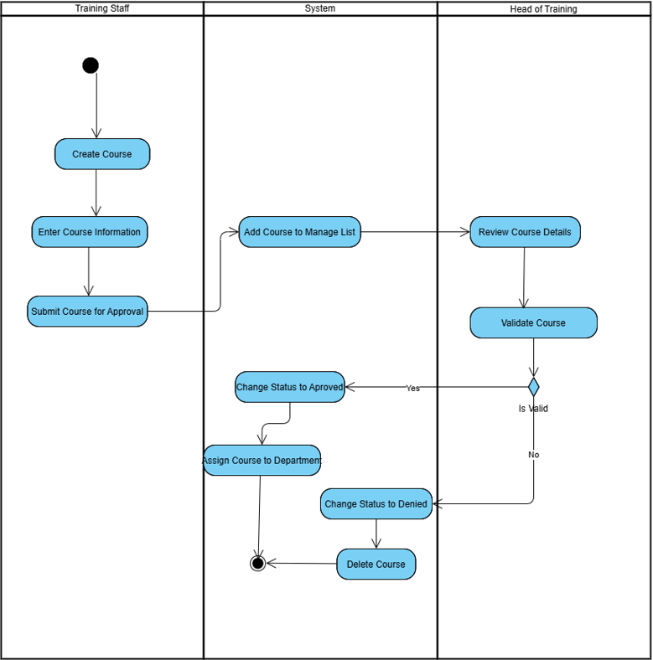
Picture 1.2.4.1. Create and Assign Courses

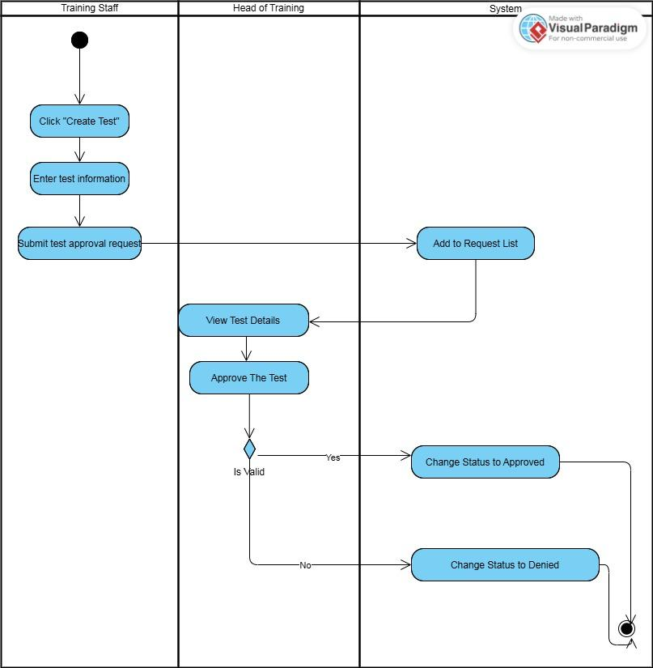
Picture 1.2.4.2. Create and Assign tests

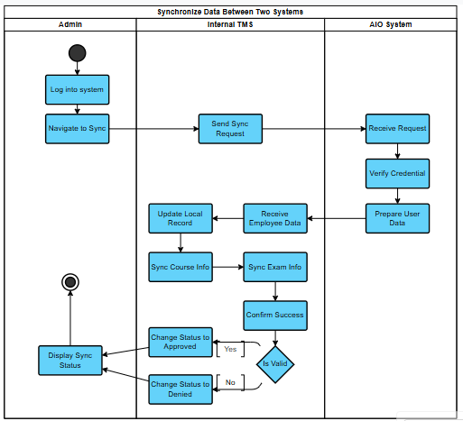
Picture 1.2.4.3. Synchronize Data Between Two Systems

1.2.5 State machine diagram
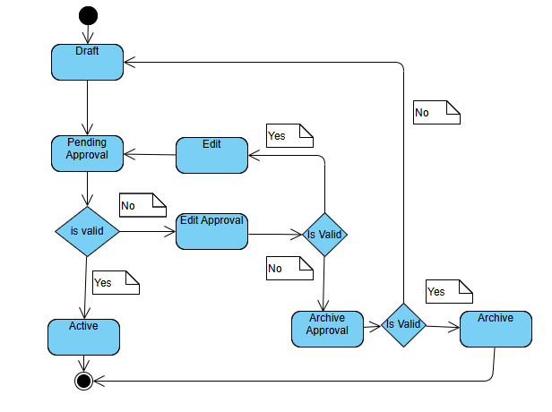
Picture 1.2.5.1. Course status lifecycle
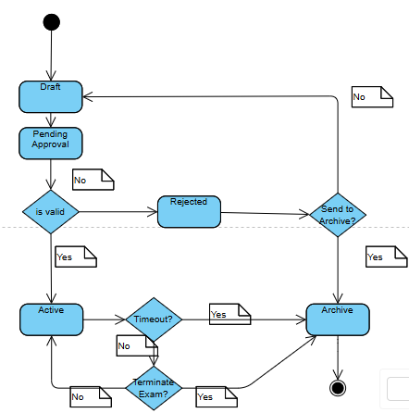
Picture 1.2.5.2. Test status lifecycle

1.3 System Functionalities

1.3.1 Screens Flow
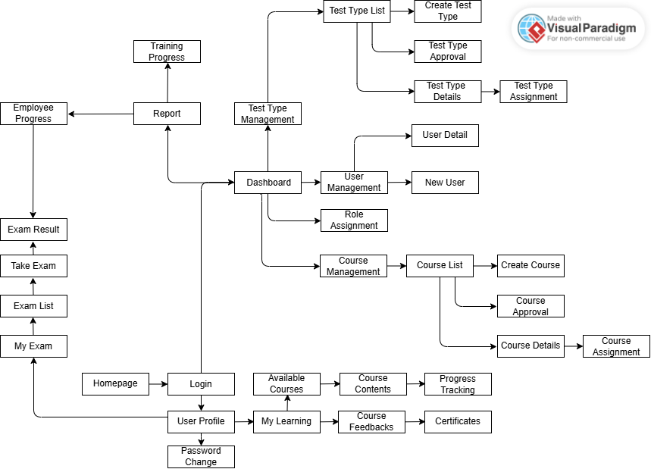
Picture 1.3.1. Screen Flow

1.3.2 Screen Descriptions

# | Feature | Screen | Description
1 | User Authentication | Homepage | The initial welcome screen that provides an access point to the login function.
2 | User Authentication | Login | Allows users to enter their credentials (username, password) to access the system.
3 | User Profile Management | User Profile | Displays and allows the user to edit their personal information.
4 | User Profile Management | Password Change | Provides a form for users to change their current password.
5 | Learning | Available Courses | Lists all courses that an employee can enroll in.
6 | Learning | My Learning | Displays the list of courses the employee is enrolled in or has completed.
7 | Learning | Course Contents | Displays the detailed content, lessons, and materials for a specific course.
8 | Learning | Progress Tracking | Displays the employee's completion progress within a specific course.
9 | Learning | Course Feedbacks | Allows employees to submit feedback or ratings for a completed course.
10 | Learning | Certificates | Allows employees to view and download their earned certificates.
11 | Exam | My Exam / Exam List | Lists all exams assigned to the employee.
12 | Exam | Take Exam | The interface for taking an exam, displaying questions and allowing answer submission.
13 | Exam | Exam Result | Displays the results and score of an exam that the employee has completed.
14 | Admin Management | Dashboard | The central dashboard for administrators, providing an overview and navigation to management functions.
15 | User Management | User Management | Displays a list of users in the system and provides management tools.
16 | User Management | New User | Provides a form to create a new user account.
17 | User Management | User Detail | Displays detailed information for a selected user.
18 | User Management | Role Assignment | Allows an administrator to assign or change user roles/permissions.
19 | Course Management | Course Management | Provides tools to monitor and manage all courses.
20 | Course Management | Course List | Displays a list of all courses in the system.
21 | Course Management | Create Course | Provides a form to create a new course.
22 | Course Management | Course Approval | Allows a manager to review and approve newly created courses.
23 | Course Management | Course Details | Displays the full, detailed information for a selected course.
24 | Course Management | Course Assignment | Allows an administrator to assign a course to specific employees or groups.
25 | Test Management | Test Type Management | Provides tools to monitor and manage all test types.
26 | Test Management | Test Type List | Displays a list of all test types in the system.
27 | Test Management | Create Test Type | Provides a form to create a new test type.
28 | Test Management | Test Type Approval | Allows a manager to review and approve new test types.
29 | Test Management | Test Type Details | Displays the full, detailed information for a selected test type.
30 | Test Management | Test Type Assignment | Allows an administrator to assign a test to specific employees or groups.
31 | Reporting | Report | The main screen for the reporting feature, providing access to various reports.
32 | Reporting | Employee Progress | Displays a summary report of employees' learning progress and exam results.
33 | Reporting | Training Progress | Displays a detailed report on the progress of training programs across the system.

1.3.3 Entity Relationship Diagram
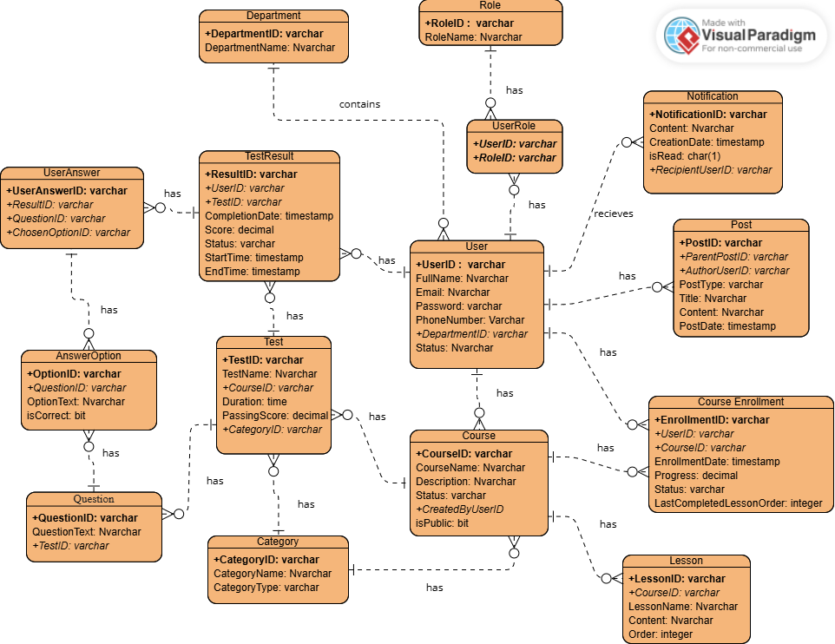
Picture 1.3.3. ERD for Internal Training Management System

Entities Description
# | Entity | Description
1 | User | Stores information about all individuals in the system, including employees, managers, and administrators. This data is synchronized from the external HR (AIO) system.
2 | Role | Defines the permission levels and access rights within the system (e.g., Admin, Employee, Training Staff, Head of Training, Department Manager, Media Staff).
3 | UserRole | A linking entity that resolves the many-to-many relationship between Users and Roles, allowing a single user to have multiple roles.
4 | Department | Represents the organizational units or departments within the company to which users belong.
5 | Category | Stores a managed list of types for courses and tests (e.g., "Technical", "Soft Skill", "Final Exam"), managed by the Administrator.
6 | Course | Contains details about a specific training course, such as its name, description, status, and type. It also tracks who created the course.
7 | Lesson | Represents a single unit of content within a course, such as a video or a document, and defines its order in the course sequence.
8 | CourseEnrollment | A linking entity that tracks which user is enrolled in which course, along with their learning progress and status.
9 | Test | Stores information about an exam or test, including its name, duration, passing score, and its association with a course and category.
10 | Question | Stores the text and details for a single question within a specific test.
11 | AnswerOption | Stores a possible answer choice for a specific question and indicates whether it is the correct one.
12 | TestResult | Stores the summary results, such as score and status, for a user's single attempt at a test.
13 | UserAnswer | A linking entity that records the specific AnswerOption a User chose for a Question during a particular TestResult (test attempt).
14 | Post | A versatile entity used to store internal news (as parent posts) and user comments (as child posts).
15 | Notification | Stores information about system-generated notifications sent to specific users, such as approval requests or new assignments.

2. Functional Specifications

2.1 System Administration

2.1.1 UC-01: View User List
Mockup
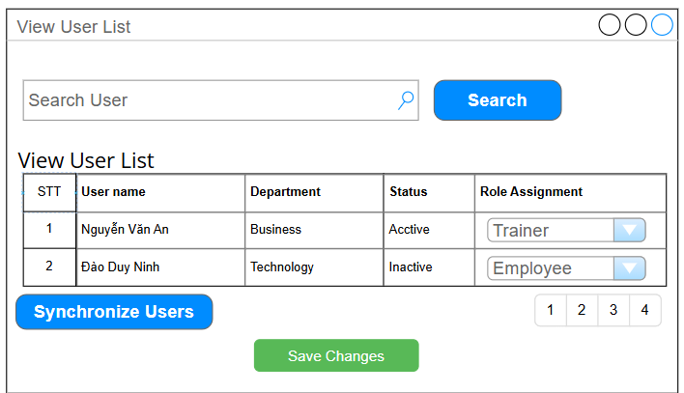
Picture 2.1.1. View User List Mockup
UI Requirement
Field Name | Field Type | Description
Search User | Text Box | Allows input to search for users by name
Search | Button | Triggers the search function
View User List | Table | Displays synchronized users
Role Assignment | Dropdown | Allows role selection for each user (e.g., Admin, Employee, Trainer)
Synchronize Users | Button | Executes user synchronization from the AIO system
Save Changes | Button | Saves changes

Functional Description Template
UC ID and Name: | UC-01: View User List
Created By: | ThangDQ | Date Created: | 25/Jun/2025
Primary Actor: | Admin | Secondary Actors: | HR System (AIO)
Trigger: | Admin clicks "Synchronize Users" or system triggers auto-sync based on schedule.
Description: | Allows administrators to synchronize users from the HR system (AIO) and assign system access roles.
Preconditions: | Administrator is logged in.  AIO synchronization API is functional.
Postconditions: | The user list is updated with the latest data.  Synchronize Users:  - User not found in AIO Then the list will show no user  - User found in AIO Then the list will show all user information  Role assignment are save.
Normal Flow: | Synchronize Users  1. Admin accesses User Management Dashboard.  2.Admin Click "Synchronize Users".  3. The system fetches and updates user data from AIO.  4. Admin Click "Save Changes" to confirm.  5. The system saves and displays the updated information.
Alternative Flows: | Role assignment  1. Admin reviews the user list displayed on the interface.  2.Admin clicks on the dropdown in the "Role Assignment" column for a specific user.  3. Admin selects a new role (e.g., Trainer, Employee, Manager, etc.) from the list.  4. After completing all role selections, admin clicks the "Save Changes" button.  5. The system validates the selected roles and updates the users' role assignments in the database.  6. The system displays a confirmation message and refreshes the list to reflect the updated roles.
Exceptions: | If AIO connection fails → error message displayed.  If the user lacks admin permission → action is blocked.
Priority: | High (Medium, Low), Must Have (Should Have, Could Have),..
Frequency of Use:
Business Rules: | BR-05, BR-11, BR-13, BR-22
Other Information: | All synchronization actions should be logged for auditing.
Assumptions: | AIO data is reliable and accurate.

2.1.2 UC-02: View Test Types List
Mockup 1
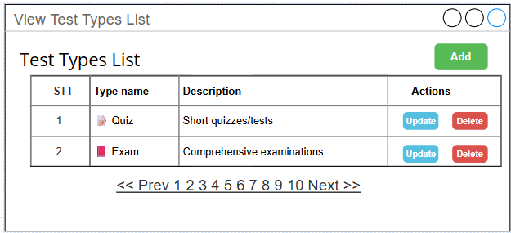
Picture 2.1.2.1. View Test Type List Mockup
Mockup 2
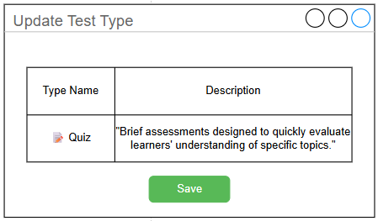
Picture 2.1.2.2. Update Test Type Mockup
Mockup 3
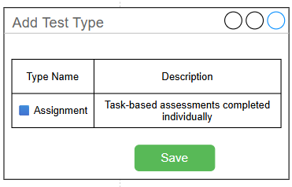
Picture 2.1.2.3. Add Test Type Mockup
UI Requirement
Field Name | Field Type | Description
Screen 1:View Test Type List
Course Type List | Table | Displays a list of Test type
Add | Button | Creates a new type Test
Update | Button | Updates the selected type
Delete | Button | Deletes the selected type
Screen 2: Update Test Type
Type Name | Textbox | Input the Test type name.
Description | Text Area | Input a detailed description of the Test type.
Save | Button | Save changes
Screen 3: Update Course Type
Type Name | Textbox | Input the Test type name.
Description | Text Area | Input a detailed description of the Test type.
Save | Button | Save changes

Functional Description Template
UC ID and Name: | UC-02: View Test Types
Created By: | ThangDQ | Date Created: | 29/Jun/2025
Primary Actor: | Admin | Secondary Actors:
Trigger: | Admin accesses the view test type interface to perform adding, updating, or deleting actions.
Description: | As an Admin, I want to view, search, add, update, and delete test types, as well as navigate through multiple pages, so that I can manage the list of test types efficiently and keep the system up to date.
Preconditions: | User is logged in with Admin role.
Postconditions: | New or modified types are saved and reflected in the system.  Lists are refreshed accordingly.
Normal Flow: | 1. Admin opens the Test Types List interface.  2. Admin chooses an action:  - Click Add to open the “Add Test Type” form. (AF-1)  - Click Update next to an item to modify it.(AF-2)  - Click Delete to remove an item.(AF-3)  3.System updates and reloads the list to reflect changes.
Alternative Flows: | AF-1: Add New Test Type  - Admin clicks the Add button on the Test Type List interface.  - The system displays the Add Test Type form.  - Admin fills in:  - Type Name (e.g., Assignment)  - Description (e.g., Task-based assessments completed individually)  - Admin clicks Save.  - System validates the input and checks for duplicates.  - If valid, the system saves the new type and the list is refreshed.  - Return to step 3 of the Normal Flow.  AF-2: Update Test Type  - Admin clicks the Update button next to a test type.  - The system displays the Update Test Type form with current values pre-filled.  - Admin edits fields (e.g., updates description of "Quiz").  - Admin clicks Save.  - System validates and updates the record.  - System redirects to the updated list view.  - Return to step 3 of the Normal Flow.  AF-3: Delete Test Type  - Admin clicks the Delete button next to a test type.  - The system prompts for confirmation (e.g., “Are you sure you want to delete this test type?”).  - Admin confirms the deletion.  - System checks:  - If the test type is not in use → proceed to delete.  - If the test type is in use → display error message: "This type is currently in use and cannot be deleted."  - After successful deletion, the system will refresh the list to reflect the changes.  - Return to step 3 of the Normal Flow.
Exceptions: | Missing required fields → validation error message.  Type in use cannot be deleted.
Priority: | High (Medium, Low), Must Have (Should Have, Could Have),..
Frequency of Use: | Weekly / Monthly
Business Rules: | BR-01, BR-03, BR-06
Other Information: | Test type changes may affect test creation, assignment settings, or reporting modules.
Assumptions: | Only authorized users can access this module.

2.1.3 UC-03: View Course Types List
Mockup 1
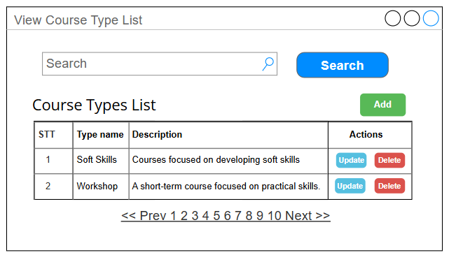
Picture 2.1.3.1. View Course Type List Mockup
Mockup 2
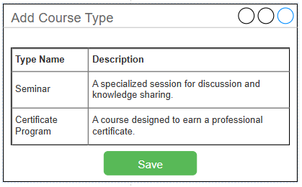
Picture 2.1.3.2. Add Course Type Mockup

Mockup 3
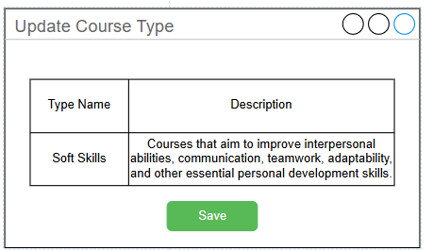
Picture 2.1.3.3. Update Course Type Mockup

UI Requirement
Field Name | Field Type | Description
Screen 1:View Course Type List
Course Type List | Table | Displays a list of courses type
Search | Textbox + Button | Allows user to search course types by name
Add | Button | Creates a new type Course
Update | Button | Updates the selected type
Delete | Button | Deletes the selected type
Screen 2: Add Course Type
Type Name | Textbox | Input the course type name.
Description | Text Area | Input a detailed description of the course type.
Save | Button | Save changes
Screen 3: Update Course Type
Type Name | Textbox | Input the course type name.
Description | Text Area | Input a detailed description of the course type.
Save | Button | Save changes

Functional Description Template
UC ID and Name: | UC-03: View Course Types
Created By: | ThangDQ | Date Created: | 29/Jun/2025
Primary Actor: | Admin | Secondary Actors:
Trigger: | Admin accesses the view course type interface to perform searching, adding, updating, or deleting actions.
Description: | As a user, I want to view, search, add, update, and delete course types, as well as navigate through multiple pages, so that I can manage the list of course types efficiently and keep the system up to date.
Preconditions: | User is logged in with Admin role.
Postconditions: | New or modified types are saved and reflected in the system.  Lists are refreshed accordingly.
Normal Flow: | 1. Admin opens the Test Types List interface.  2. Admin chooses an action:  - Click Add to open the “Add Test Type” form. (AF-1)  - Click Update next to an item to modify it.(AF-2)  - Click Delete to remove an item.(AF-3)  3.System updates and reloads the list to reflect changes.
Alternative Flows: | AF-1: Add New Test Type  1.Admin clicks the Add button on the Test Type List interface.  2.The system displays the Add Test Type form.  3.Admin fills in:  - Type Name (e.g., Assignment)  - Description (e.g., Task-based assessments completed individually)  4.Admin clicks Save.  5.System validates the input and checks for duplicates.  6.If valid, the system saves the new type and the list is refreshed.  7.Return to step 3 of the Normal Flow.  AF-2: Update Test Type  1.Admin clicks the Update button next to a test type.  2.The system displays the Update Test Type form with current values pre-filled.  3.Admin edits fields (e.g., updates description of "Quiz").  4.Admin clicks Save.  5.System validates and updates the record.  6.System redirects to the updated list view.  7.Return to step 3 of the Normal Flow.  AF:3 Delete Test Type  1.Admin clicks the Delete button next to a test type.  2.The system prompts for confirmation (e.g., “Are you sure you want to delete this test type?”).  3.Admin confirms the deletion.  4.System checks:  - If the test type is not in use → proceed to delete.  - If the test type is in use → display error message: "This type is currently in use and cannot be deleted."  5.After successful deletion, the system will refresh the list to reflect the changes.  6.Return to step 3 of the Normal Flow.
Exceptions: | Missing required fields → validation error message.  Type in use cannot be deleted.
Priority: | High (Medium, Low), Must Have (Should Have, Could Have),..
Frequency of Use: | Weekly / Monthly
Business Rules: | BR-01, BR-03, BR-06
Other Information: | Type changes may affect related assignment features.
Assumptions: | Only authorized users can access this module.

2.2 Course and Test Management

2.2.1 UC-04: Create Course
Mockup
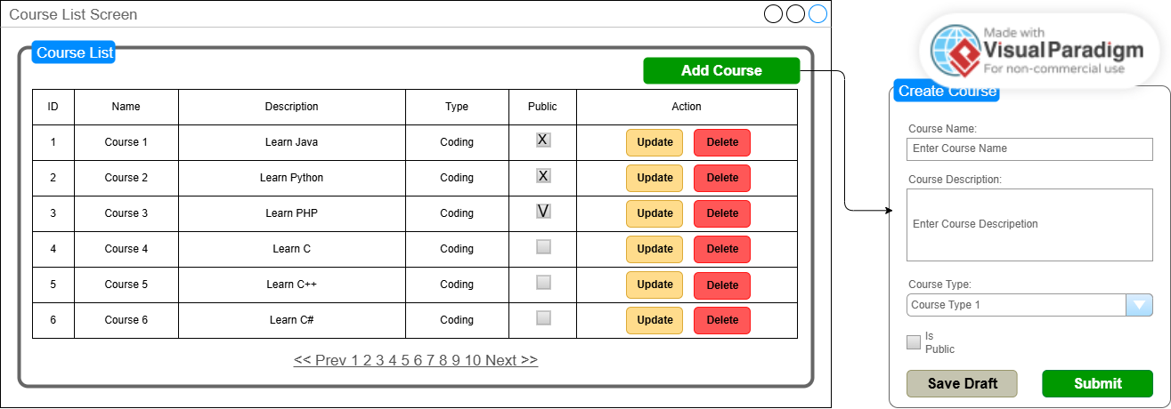
Picture 2.2.1. Create Course Mockup
UI Requirement
Field Name | Field Type | Description
Course Name | Textbox | Input the name of the course
Description | Text Area | Provide a detailed description of the course
Course Type | Dropdown | Select the course type
Is Public | Checkbox | Optional: mark course as public
Add Course | Button | Save and create the course in the system
Update | Button | Update selected course
Delete | Button | Delete selected course
Save Draft | Button | Save course with “Draft” status
Submit | Button | Submit course as “Pending” or “Public”
Course List | Table | Show all existing courses with actions

Functional Description
UC ID and Name: | UC-04: Create Course
Created By: | ThaoNP | Date Created: | 25/Jun/2025
Primary Actor: | Training Staff, Head of Training | Secondary Actors: | Employees
Trigger: | Training Staff's course will be saved as Pending or Draft, while Head of Training's course will be published as Public immediately. The user can either Save as Draft or Submit the course depending on role and intent.
Description: | Allows Users to add new training courses with detailed information, including course name, type, description, and public status. The course is added directly into the system and can then be sent for approval
Preconditions: | PRE-1 User is logged in as Training Staff or Training Manager role  PRE-2 At least one course type exists
Postconditions: | POST-1 A course is saved in the system in one of the states: Draft, Pending, or Public  POST-2 The course appears in the course list accordingly
Normal Flow: | - The user accesses the “Course Management” page  - The system displays “Course List” screen  - The user clicks [Add Course] button  - The system display “Create Course” modal  -> If the user close the modal at this step -> AF-1  - The user fills in course name, description, selects course type, and optionally marks as Public (optional)  - The user clicks [Save Draft] button  - 6a. The user clicks [Save Draft] button -> the system will save the course with “Draft” status  - 6b. The user clicks [Submit]  - If the user logs in Training Staff -> course “Pending” status  - If the user logs in Head of Training -> course “Public” status  - The system validates the input fields  -> If any input is invalid -> AF-2  - The system attempts to save the course  -> If the system error occurs -> E-1  - The course is saved successfully and the course list is updated  - The system shows success message
Alternative Flows: | AF-1 User closes the modal  AF-2 Form submitted with invalid/missing input  -> The system shows inline error messages
Exceptions: | E-1 Failure during saving (e.g., network or DB error)  → System shows: “Unable to save course. Please try again.”
Priority: | Must Have
Frequency of Use: | Weekly/Monthly
Business Rules: | BR-01, BR-06, BR-23
Other Information: | Course data becomes accessible for validation and assignment immediately after creation
Assumptions: | At least one course type is available in the system

2.2.2 UC-05: Create Test
Mockup
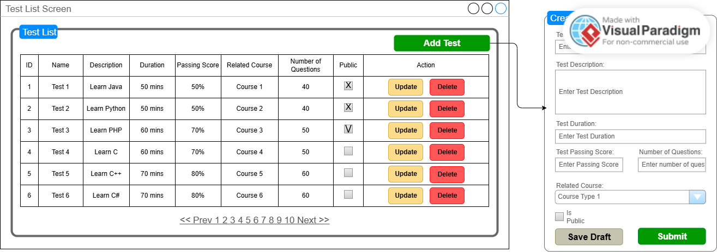
Picture 2.2.2. Create Test Mockup

UI Requirement
Field Name | Field Type | Description
Test Name | Textbox | Input the name of the test
Description | Text Area | Briefly describe the test purpose or scope
Duration (min) | Number | Time limit for the test in minutes
Passing Score | Percentage | Minimum score (%) required to pass
Related Course | Dropdown | Select the course associated with this test
Number of Questions | Numeric | Specify number of questions
Is Public | Checkbox | Optional: mark test as public
Add | Button | Save and create the test in the system
Update | Button | Update selected test
Delete | Button | Delete selected test
Save Draft | Button | Save test as draft
Submit | Button | Submit test for approval or publish
Test List | Table | Show all existing tests with actions

Functional Description Template
UC ID and Name: | UC-05: Create Test
Created By: | ThaoNP | Date Created: | 25/Jun/2025
Primary Actor: | Training Staff, Head of Training | Secondary Actors: | Employees
Trigger: | Training Staff's test will be saved as Pending or Draft, while Head of Training's test will be published as Public immediately. The user can either Save as Draft or Submit the test depending on role and intent.
Description: | Allows Users to add new tests with detailed information, including test name, description, duration, passing score, related course, number of questions, and public. The test is added directly into the system and can then be sent for approval
Preconditions: | PRE-1 User is logged in as Training Staff or Training Manager role  PRE-2 At least one course exists to associate the test with
Postconditions: | POST-1 A course is saved in the system in one of the states: Draft, Pending, or Public  POST-2 The test appears in the test list accordingly
Normal Flow: | - The user accesses the “Test Management” page  - The system displays “Test List” screen  - The user clicks [Add Test] button  - The system display “Create Test” modal  -> If the user close the modal at this step -> AF-1  - The user fills in course name, description, duration, passing score, number of questions, and optionally marks as Public (optional)  - The user clicks [Save Draft] button  - 6a. The user clicks [Save Draft] button -> the system will save the test with “Draft” status  - 6b. The user clicks [Submit]  - If the user logs in Training Staff -> test “Pending” status  - If the user logs in Head of Training -> test “Public” status  - The system validates the input fields  -> If any input is invalid -> AF-2  - The system attempts to save the test  -> If the system error occurs -> E-1  - The test is saved successfully and the test list is updated  - The system shows success message
Alternative Flows: | AF-1 User closes the modal  AF-2 Form submitted with invalid/missing input  -> The system shows inline error messages
Exceptions: | E-1 Failure during saving (e.g., network or DB error)  → System shows: “Unable to save course. Please try again.”
Priority: | Must Have
Frequency of Use: | Weekly/Monthly
Business Rules: | BR-01, BR-06, BR-24, BR-25
Other Information: | Test data becomes accessible for validation and assignment immediately after creation
Assumptions: | At least one course exists to associate the test with

2.2.3 UC-06: Validate Course & Test
Mockup
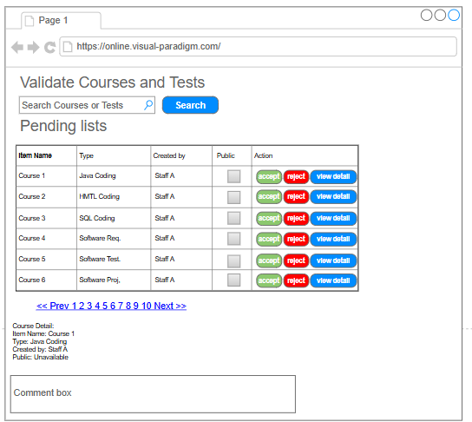
Picture 2.2.3. Validate Course & Test Mockup

UI Requirement
Field Name | Field Type | Description
Select Course/Test | Dropdown | Choose to filter validation items by type
Search | Button | Trigger search of pending items
Item Table | Table | Display list of courses/tests pending validation
View Details | Button | Show full details of selected course or test
Approve | Button | Validate the selected course/test and make it active
Reject | Button | Reject and move item back to Draft
Comment Box | Text Area | Optional reason for rejection, required when rejecting

Functional Description Template
UC ID and Name: | UC-06: Validate Course & Test
Created By: | Vũ Nguyễn Minh | Date Created: | 25-06-2025
Primary Actor: | Head of Training | Secondary Actors: | Training Staff
Trigger: | A new course or test is submitted for approval
Description: | This use case allows the Head of Training to validate submitted courses or tests before they become active.
Preconditions: | User is logged in as Head of Training; course/test is in Pending Approval state
Postconditions: | Item is either marked as Active (if approved) or returns to Draft (if rejected)
Normal Flow: | 1. User logs in  2. Opens validation page  3. Selects item  4. Views details  5. Clicks Approve or Reject
Alternative Flows: | If rejected, the user must provide a comment before submission
Exceptions: | If the course/test data is invalid or missing, error is shown
Priority: | High (Must have).
Frequency of Use: | Daily/Weekly depending on content upload frequency
Business Rules: | Only Head of Training can validate; comments are mandatory for rejection
Other Information: | Courses/tests can only be edited again if rejected
Assumptions: | Head of Training has full view access to all submitted materials

2.2.4 UC-07: Assign Course & Test to Employees
Mockup
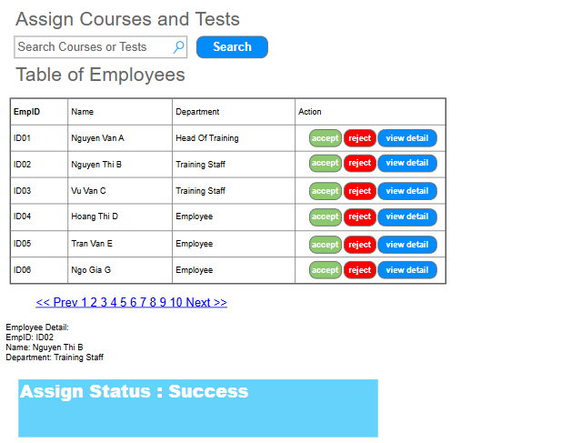
Picture 2.2.4. Create Test Mockup

UI Requirement
Field Name | Field Type | Description
Select Course/Test | Dropdown | Choose which course or test to assign
Search | Button | Trigger filtering based on criteria
Employee Table | Table | List of employees with selection checkboxes
View Details | Button | Show full details of selected employee
Accept | Button | Validate the employee and assign to course
Reject | Button | Reject Employee
Employee Detail | Label/ Message | Show details of Employees
Assignment Status | Label/Message | Displays result of assignment (success/failure)

Functional Description Template
UC ID and Name: | UC-07: Assign Course & Test to Employees
Created By: | Vũ Nguyễn Minh | Date Created: | 25-06-2025
Primary Actor: | Training Staff / Head of Training | Secondary Actors: | Employee
Trigger: | Course or test is active and ready for assignment
Description: | Assign courses or tests to one or more employees or departments for learning and tracking.
Preconditions: | Course/test must be in "Active" state
Postconditions: | Assigned employees receive notifications and can view assigned items
Normal Flow: | 1. User logs in  2. Opens assignment page  3. Selects course/test  4. Selects employees  5. Clicks Assign
Alternative Flows: | Can also filter employees by department
Exceptions: | If selected course/test is not Active, show error
Priority: | High (Must Have),..
Frequency of Use: | Regular (upon course/test activation)
Business Rules: | Only active courses/tests can be assigned; only authorized users may assign
Other Information: | Assigned items appear in "My Learning" of employee
Assumptions: | System has up-to-date employee data synced from HR

2.3 Employee Learning & Assessment

2.3.1 UC-08: Enroll Courses
Mockup
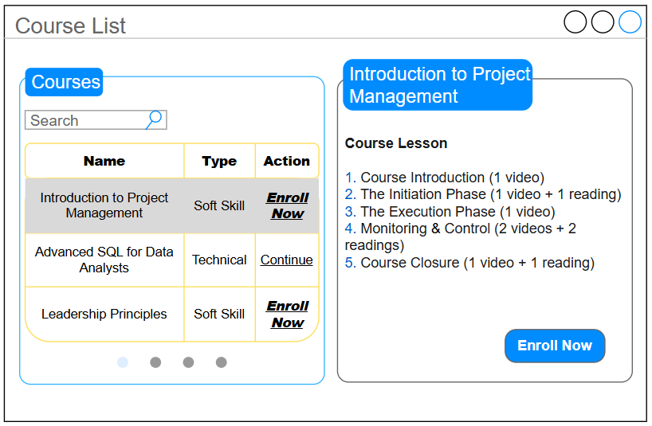
Picture 2.3.1. Enroll Courses Mockup

UI Requirement
Field Name | Field Type | Description
Search | Text Box | Allows the user to filter the course list by name.
Course List | Table/List | Displays a list of courses with their Name, Type, and a primary Action. The selected course is highlighted.
Action (in list) | Hyperlink/Button | The primary, quick-action button. "Enroll Now" for new courses, "Continue" for in-progress courses.
Course Detail Pane | Display Area | The right-hand pane that dynamically displays the details of the course selected from the list.
Course Lesson | List | A summary list of lessons for the selected course, showing the number and type of materials.
Enroll Now (in pane) | Button | A secondary, confirmation button in the detail pane for enrolling in a new course after reviewing its details.

Functional Description Template
UC ID and Name: | UC-08: Enroll & Track Learning Process
Created By: | ThangND | Date Created: | 25/Jun/2025
Primary Actor: | Employee | Secondary Actors:
Trigger: | User navigates to the "My Courses" or "Course List" page from the main menu.
Description: | As an Employee, I want to view all available courses, see details, enroll, and track my learning progress on a single, integrated screen so that I can manage my training efficiently.
Preconditions: | PRE-1 User is logged into the system.
Postconditions: | POST-1 The user's enrollment status for a course is updated.  POST-2 The user is granted access to the learning materials of the enrolled course.
Normal Flow: | 1. User accesses the "Course List" page.  2. The system displays the list of available courses in the left pane.  3. User identifies a course they want to join and directly clicks the "Enroll Now" button in the "Action" column of the course list.  4. The system validates the user's eligibility and creates a CourseEnrollment record.  5. The UI updates in real-time:  - A "Successfully Enrolled" message is shown.  - The action in the left pane for that course changes from "Enroll Now" to "Continue".  - If that course was selected, the main button in the right pane also updates to "Continue".
Alternative Flows: | AF-1 Enroll after Viewing Details  1. User accesses the "Course List" page.  2. User clicks on the name of a course (e.g., "Introduction to Project Management") to view its details.  3. The right pane updates to show the details for the selected course, including the "Course Lesson" summary.  4. After reviewing the details, the user clicks the "Enroll Now" button located inside the right-hand detail pane.  5. Return to step 4 of the Normal Flow.  AF-2 Continue an In-Progress Course  1. From the course list, the user clicks the "Continue" button for a course they are already enrolled in.  2. The system navigates the user to the detailed learning interface for that course, showing their current progress and the next available lesson..
Exceptions: | E-1 Enrollment Failed  1. At step 4 of the Normal Flow (or step 5 of Alternative Flow 8.1), if the system cannot process the enrollment.  2. The system displays an error message (e.g., "Enrollment failed. Please try again later.") and the UI does not change.
Priority: | Must Have
Frequency of Use: | High
Business Rules: | BR-02, BR-08, BR-17
Other Information: | The Normal Flow represents a "quick action" for users who already know which course they want, while the Alternative Flow is for users who need more information before committing.
Assumptions: | The system can handle both enrollment triggers and update the UI consistently.

2.3.2 UC-09: Take the Tests
Mockup 1
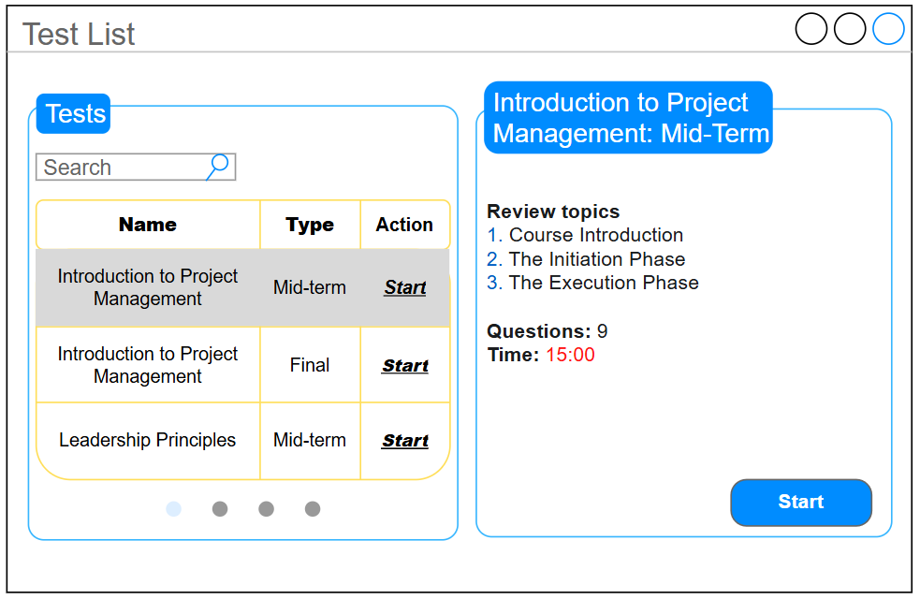
Picture 2.3.2.1. Test Selection Mockup
Mockup 2
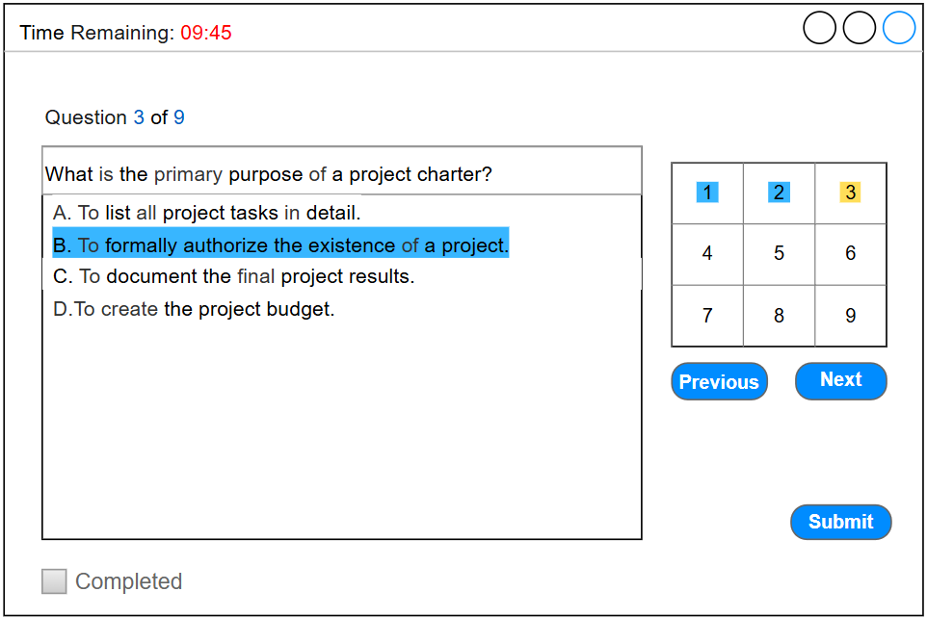
Picture 2.3.2.2. Test in Progress Mockup

UI Requirement
Field Name | Field Type | Description
Screen 1: Test Selection
Search | Text Box | Allows the user to filter the test list by name.
Test List | Table/List | Displays a list of available tests with their Name, Type, and a primary Action. The selected test is highlighted.
Action (in list) | Hyperlink/Button | The primary, quick-action button to start a test directly from the list.
Screen 2: Test in Progress
Time Remaining | Text Display | A prominent countdown timer showing the time left.
Question Navigation Grid | Button Grid | A grid of numbers allowing the user to jump directly to any question. The current question is highlighted.
Answer Options | Radio Buttons | The set of possible answers for the current question.
Completed Checkbox | Checkbox | A mandatory checkbox that the user must tick to enable the "Submit" button for manual submission.
Submit | Button | The final button to submit the exam. It is disabled until the "Completed" checkbox is ticked

Functional Description Template
UC ID and Name: | UC-09: Take the Tests
Created By: | ThangND | Date Created: | 25/Jun/2025
Primary Actor: | Employee | Secondary Actors:
Trigger: | User navigates to the "Test List" or "My Exams" page from the main menu.
Description: | As an Employee, I want to view a list of my assigned tests, review their requirements, and take the timed test in an interactive interface to complete my assessments
Preconditions: | PRE-1 User is logged into the system.  PRE-2 User has met all prerequisites for the exam (e.g., completed required lessons).
Postconditions: | POST-1 A TestResult record is created with the user's score and status.  POST-2 The user's test attempt history is updated.
Normal Flow: | 1. User accesses the "Test List" page.  2. The system displays the list of available tests in the left pane.  3. User identifies a test they want to take and directly clicks the "Start" button in the "Action" column of the test list.  4. The system validates the user's eligibility (prerequisites met).  5. The system navigates the user to the "Test in Progress" screen (Mockup 2) and starts the countdown timer. The "Submit" button is disabled.  6. User takes the test and submits it (as per the logic defined in the next flow).
Alternative Flows: | AF-1 Start after Viewing Details  1. User accesses the "Test List" page.  2. User clicks on the name of a test (e.g., "Introduction to Project Management: Mid-term") to view its details.  3. The right pane updates to show the details for the selected test, including topics to review, number of questions, and time limit.  4. After reviewing the details, the user clicks the "Start" button located inside the right-hand detail pane.  5. Return to step 4 of the Normal Flow.  AF-2 Take the Exam and Submit Manually  1. Once on the "Test in Progress" screen, the user answers questions using the navigation controls.  2. After reviewing all answers, the user ticks the "Completed" checkbox.  3. The "Submit" button becomes enabled.  4. The user clicks "Submit" and confirms the action.  5. The system grades the test, creates a TestResult record, and displays the result page.  AF-3 Time Expires (Auto-Submit)  1. While the user is taking the exam, the "Time Remaining" timer reaches 00:00.  2. The system automatically submits the exam, regardless of the "Completed" checkbox status.  3. Return to step 5 of Alternative Flow 7.2.
Exceptions: | E-1 Prerequisites Not Met  1. At step 4 of the Normal Flow (or step 5 of Alternative Flow 7.1), if the user is not eligible to start the test.  2. The system displays an error message: "You must complete all required lessons before taking this test." The user remains on the test selection screen.
Priority: | Must Have
Frequency of Use: | Medium
Business Rules: | BR-02, BR-09, BR-10, BR-16
Other Information: | The Normal Flow represents a "quick action" for users who are ready to start immediately, while the Alternative Flow is for users who need to review test details first.
Assumptions:

2.3.3 UC-10: Track Learning Process
Mockup
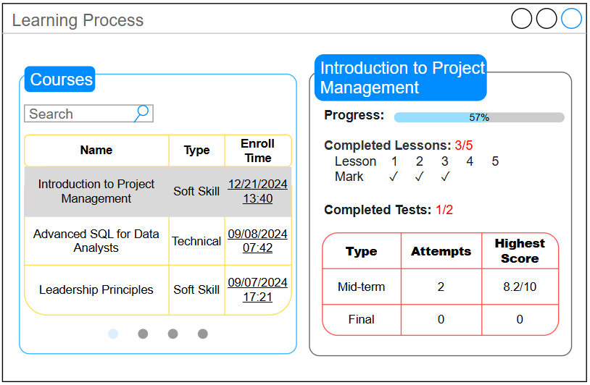
Picture 2.3.3. Learning Process Mockup

UI Requirement
Field Name | Field Type | Description
Course List | Table/List | Displays a list of courses the user has enrolled in, showing Name, Type, and Enroll Time. The selected course is highlighted.
Progress | Progress Bar | A visual representation of the overall completion percentage for the selected course.
Completed Lessons | Text Display & Icons | Shows the number of completed lessons out of the total (e.g., 3/5) and uses checkmark icons (✓) to indicate which specific lessons are done.
Completed Tests | Text Display & Table | Shows the number of completed tests out of the total (e.g., 1/2) and provides a table summarizing the results for each test (Type, Attempts, Highest Score).

Functional Description Template
UC ID and Name: | UC-10: Track Learning Process
Created By: | ThangND | Date Created: | 25/Jun/2025
Primary Actor: | Employee | Secondary Actors:
Trigger: | User navigates to the "My Progress" or "Learning Process" page from the main menu.
Description: | As an Employee, I want to track my overall learning progress for all enrolled courses on a single dashboard, so I can easily see what I have completed and what is still pending.
Preconditions: | PRE-1 User is logged into the system.  PRE-2 User has enrolled in at least one course.
Postconditions: | POST-1 The user has a clear, up-to-date overview of their training status.
Normal Flow: | 1. User accesses the "Learning Process" page.  2. The system displays the list of the user's enrolled courses in the left pane. The first course in the list is selected by default.  3. The right pane updates to show a detailed progress summary for the selected course. This includes:  - The overall Progress bar.  - A summary of Completed Lessons.  - A table summarizing Completed Tests, including number of attempts and highest score for each.  4. User clicks on another course in the list (e.g., "Advanced SQL for Data Analysts").  5. The right pane dynamically updates to show the progress summary for the newly selected course.
Alternative Flows:
Exceptions: | E-1 No Enrolled Courses  1. At step 2 of the Normal Flow, if the user has not enrolled in any courses yet.  2. The system displays a message: "You have not enrolled in any courses. Please visit the Course List to get started."
Priority: | Must Have
Frequency of Use: | Medium
Business Rules: | BR-03, BR-10, BR-15, BR-17
Other Information: | This screen acts as a high-level dashboard for the employee to monitor their own performance and training history. It aggregates data from both CourseEnrollment and TestResult entities.
Assumptions: | The system can accurately calculate and retrieve the highest score from multiple test attempts for the summary table.

2.4 Reporting and Monitoring

2.4.1 UC-11: Monitor Employee Progress
Mockup
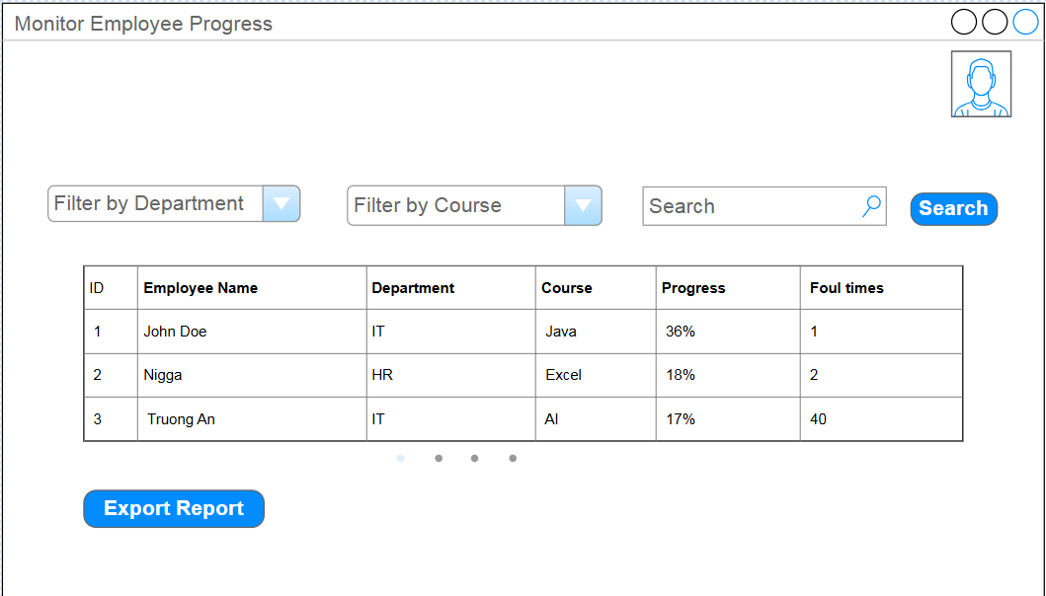
Picture 2.4.1. Monitor Employee Progress Mockup

UI Requirement
Field Name | Field Type | Description
Avatar | Image | Show avatar of user.
Filter by Department | Dropdown | Filter employee list by department
Filter by Course | Dropdown | Filter by course
Search | Text Box | Quick search by employee name or ID
Employee List Table | Table | Displays employee information and learning progress
Progress Indicator | Progress Bar | Visually shows course completion percentage for each employee
Export Report | Button | Export learning progress report to file (Excel, PDF)

Functional Description Template
UC ID and Name: | UC-11: Monitor Employee Progress
Created By: | AnNT | Date Created: | 25/Jun/2025
Primary Actor: | Department Manager, Head of Training | Secondary Actors: | Employee
Trigger: | Manager or Head of Training accesses the employee progress monitoring function
Description: | Allows Department Managers or Head of Training to monitor learning progress and exam results of employees in their department or the entire organization, supporting report export.
Preconditions: | - PRE-1: User is logged in with a valid role (Department Manager, Head of Training).  - PRE-2: Have at least 1 employee studying 1 subject.
Postconditions: | - POST-1: The system displays a list of employees with details on progress, exam results, and course completion status.  - POST-2: Progress report is exported successfully if user selects "Export Report".
Normal Flow: | 1.0 Monitor Employee Progress  - User accesses the "Monitor Employee Progress" screen.  - User selects department/course filters as needed.  - User enters a search keyword or views the complete list.  - The system displays employee information and progress details.  - User clicks [Export Report] to download a report file.  - The system generates and provides the report for download.
Alternative Flows: | 1.1 If no filter is selected, the system displays all employees visible to the user.  1.2 User filters by course to view progress for a specific course only.
Exceptions: | 1.0.E1 No matching progress data found: system displays "No results found".  1.0.E2 User does not have access rights: system denies access and redirects to error page.
Priority: | Must Have
Frequency of Use: | Daily/Weekly as required by management
Business Rules: | BR-03, BR-04, BR-17, BR-19
Other Information: | - Department Managers may only view progress for employees in their own department.  - The Head of Training can view all progress for employees in all departments.
Assumptions: | Progress data is synced and updated in real-time.

2.5 Internal News Management

2.5.1 UC-12: View Notifications List
Mockup
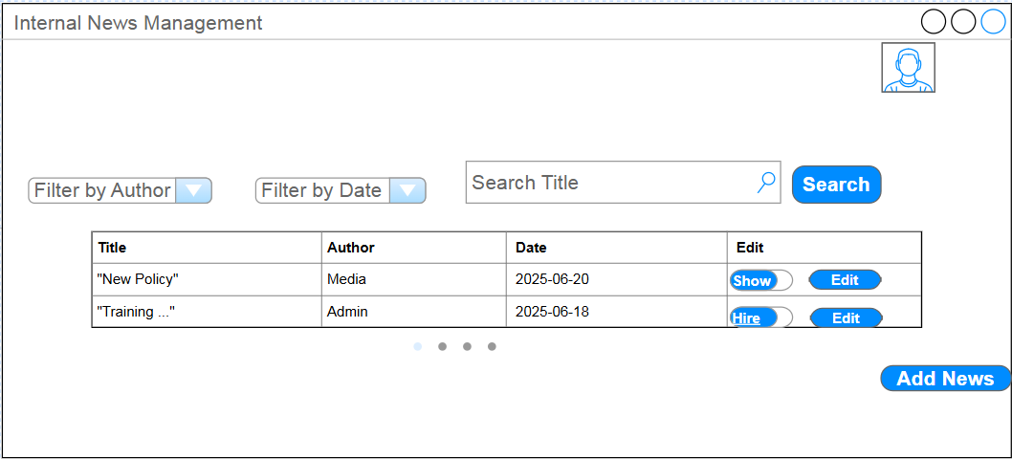
Picture 2.5.1. View Notifications List Mockup
UI Requirement
Field Name | Field Type | Description
Avatar | Image | Show avatar of user.
Filter by Author | Dropdown | Filter articles by author.
Filter by Date | Date Picker | Filter articles by publish date or date range.
Search Title | Text Box | Search articles by title.
Add News | Button | Open the form to create a new article.
News List Table | Table | Displays the filtered list of articles.
Edit | Button | Edit an article.
Show-Hire Button | Button | Adjust the status of the notification post to show or hide.
Title | Text | Article title.
Author | Text | Article author.
Date | Date | Date of publication.

Functional Description Template
UC ID and Name: | UC-12: Manage News
Created By: | AnNT | Date Created: | 25/Jun/2025
Primary Actor: | Media Staff | Secondary Actors: | All users (view news), Admin (moderation)
Trigger: | Media Staff accesses internal news management function
Description: | Allows Media Staff to view and manage display internal news articles related to training activities. The list supports filtering by author, by date, and searching by title, ensuring efficient news management and timely communication across the organization
Preconditions: | - PRE-1: Media Staff has successfully logged in.  - PRE-2: User has the required permissions to view and manage display articles.
Postconditions: | - POST-1: New articles are saved and displayed on the news page.  - POST-2: Display Management articles are updated for all users.  - POST-3: Users can filter articles by author, date, or search by title.
Normal Flow: | 1.0 Manage News  - Media Staff accesses the News Management screen.  - Uses [Filter by Author], [Filter by Date], or [Search Title] to find specific articles.  - News List Table displays filtered articles according to selected criteria.  - Clicks [Add News] to create a new article.  - To edit, Media Staff clicks buttons for a specific article.  - To manage display, Media Staff clicks a button for change status( show-hire).
Alternative Flows: | 1.1 Admin may access this module to moderate or remove inappropriate articles.  1.2 If no filters are selected, all articles are shown.
Exceptions: | 1.0.E1 Missing required information when creating/editing: system displays error message.  1.0.E2 Attempt to delete article without permission: system blocks the action and displays error.  1.0.E3 No articles match filter criteria: system displays "No results found".
Priority: | Must Have
Frequency of Use: | Weekly/Monthly depending on news update frequency
Business Rules: | BR-12, BR-21
Other Information: | All users can view news; only Media Staff may create/edit/delete.
Assumptions: | Published articles are visible to all users and may support commenting/voting if enabled.

3. Non-Functional Requirements

3.1 External Interfaces
- HR System (AIO) Interface: The system will have a critical external interface with the company's HR System (AIO) to synchronize employee information.
  - Data Input: The Internal Training Management System will receive employee data (including Employee ID, Full Name, Email, Department, and login credentials) from the AIO System. This synchronization process can be triggered manually by an Administrator or scheduled to run automatically (e.g., nightly).
  - Communication Protocol: Communication will be established via a RESTful API.
  - Data Format: The data exchange format will be JSON. Detailed API documentation from the AIO System provider is required for implementation.

3.2 Quality Attributes
1. Performance
- Response Time: All primary pages (e.g., Dashboard, Course List, My Learning) must load in under 3 seconds over a standard corporate network connection.
- Query Processing: System search queries (e.g., searching for courses or users) must return results in under 2 seconds, assuming a database size of up to 1,000 users and 10,000 course records.
2. Security
- Access Control: The system must strictly enforce Role-Based Access Control (RBAC). Users must only be able to access data and perform actions that are explicitly permitted for their assigned role(s), as defined in the business rules (e.g., BR-03, BR-04, BR-07).
- Data Protection: All sensitive data, especially user passwords, must be securely hashed and salted before being stored in the database. All communication between the client (browser) and the server must be encrypted using the HTTPS protocol.
3. Usability
- Consistency and Learnability: The user interface must be consistent across the entire application in terms of layout, color schemes, and button terminology. A new user should be able to learn how to perform basic tasks (e.g., find a course, check progress) within 15 minutes without requiring detailed training.
- Error Handling: The system must provide clear, user-friendly, and instructive error messages. Instead of displaying technical error codes, messages should help the user understand the problem and how to resolve it (e.g., "Course Name is a required field and cannot be empty.").
4. Availability
- Uptime: The system must maintain an availability of 99.5% during standard business hours (8:00 AM to 5:30 PM, Monday to Friday).
- Maintenance: Any planned maintenance that will cause system downtime must be scheduled outside of business hours and communicated to all users at least 24 hours in advance.

